**ELEPHANT BLINKY-BOT INSTRUCTABLE**

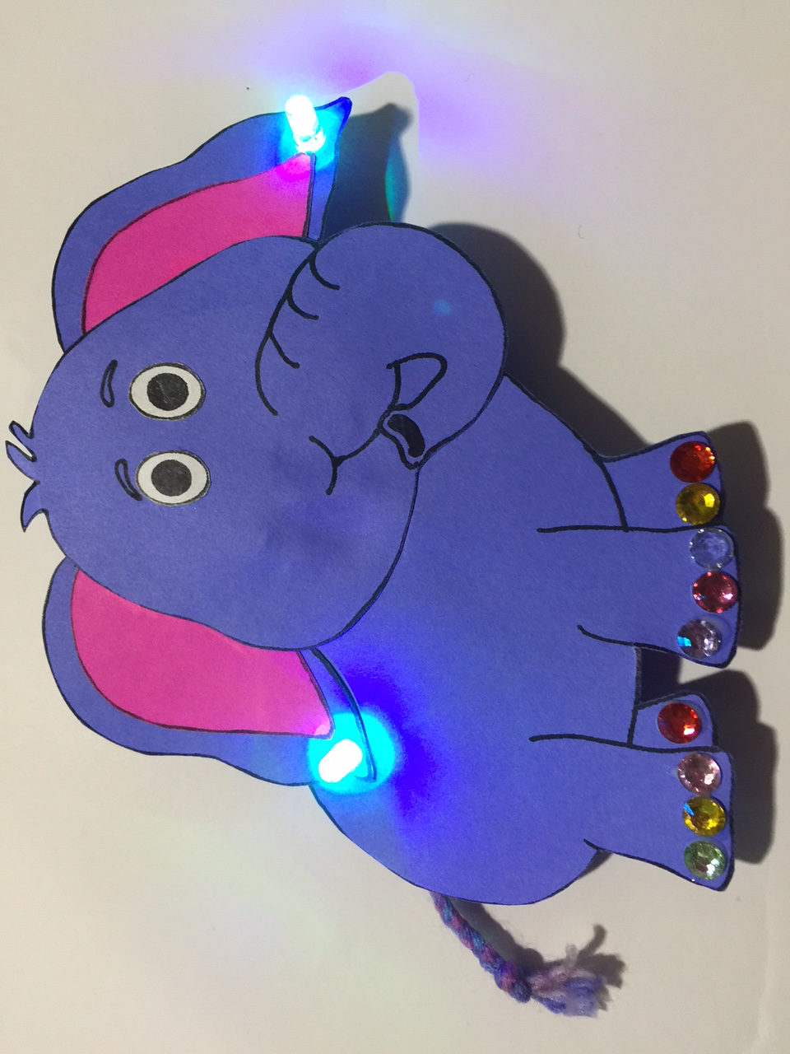

**WESTERN CANADIAN**

**ROBOTICS SOCIETY**

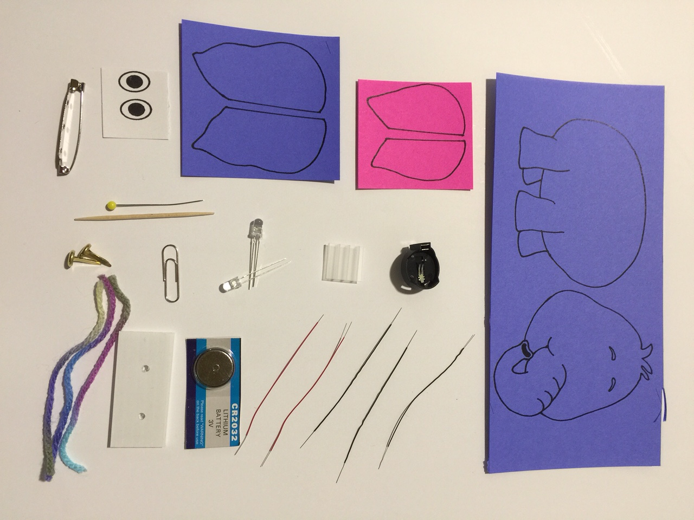

Get the supplies:

1 – elephant body and head printed on purple cardstock

1 – pair elephant inner ears printed on pink cardstock

1 – pair elephant outer ears printed on purple cardstock

1 – pair eyes printed on white cardstock

3 – 3 inch pieces of black AWG 30 wire (stripped 1/4 - 3/8 inch on both ends)

2 – 3 inch pieces of red AWG 30 wire (stripped 1/4 - 3/8 inch on both ends)

1 – coin cell battery holder

1 – 3V coin cell battery (CR 2032)

2 – fast blink multi-colored LEDs

1 – paper clip

2 – brads (~1/2 inch)

1 – 1 inch x 2 inch corrugated cardboard or plastic piece, with 2 holes punched 1 inch apart

1 – 3/4 x3/4 inch square corrugated cardboard or plastic piece

1 – bar pin

3 – 4 inch pieces of yarn

1 – toothpick

1 – straight pin

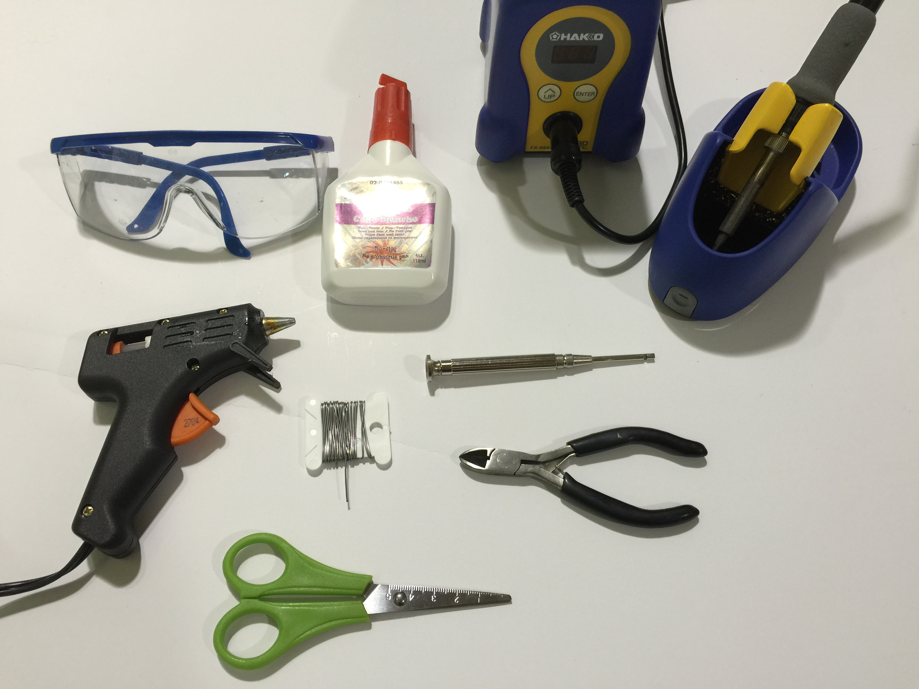

Assemble the tools:

safety glasses

hot glue gun

white glue or glue stick

scissors

wire cutters

wire wrap tool

soldering iron

solder

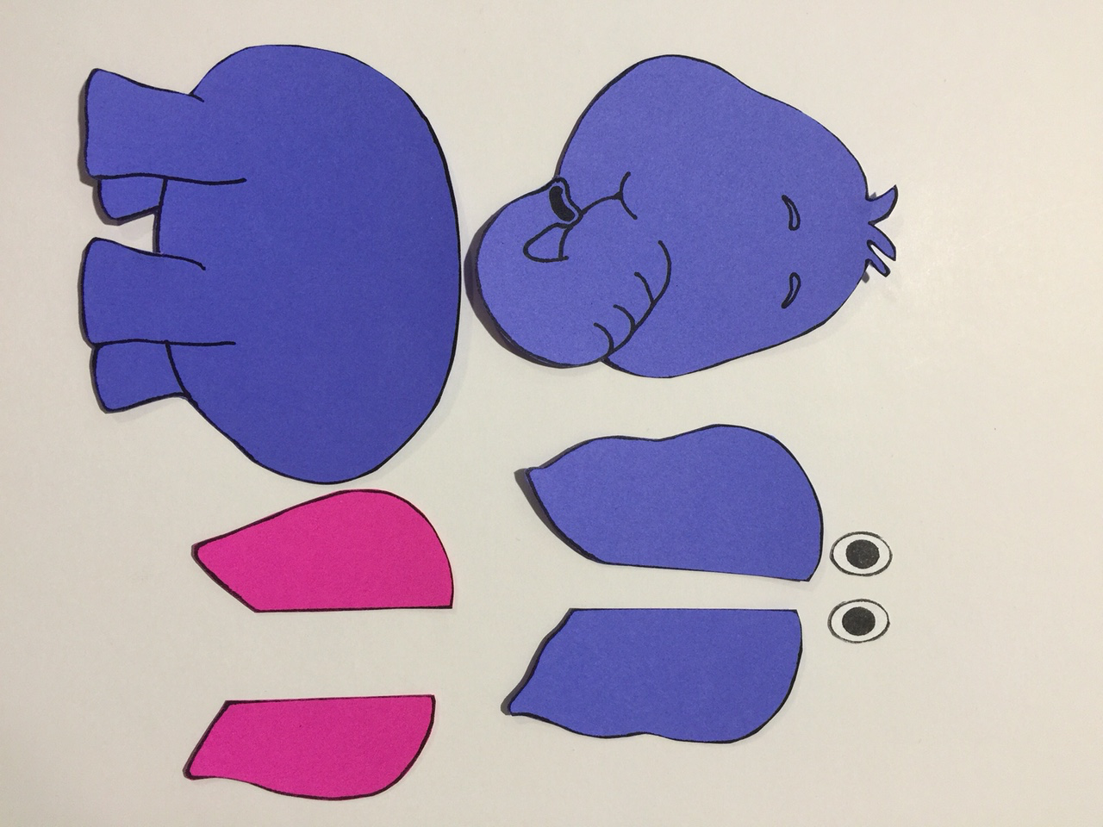

1. Cut out pieces.

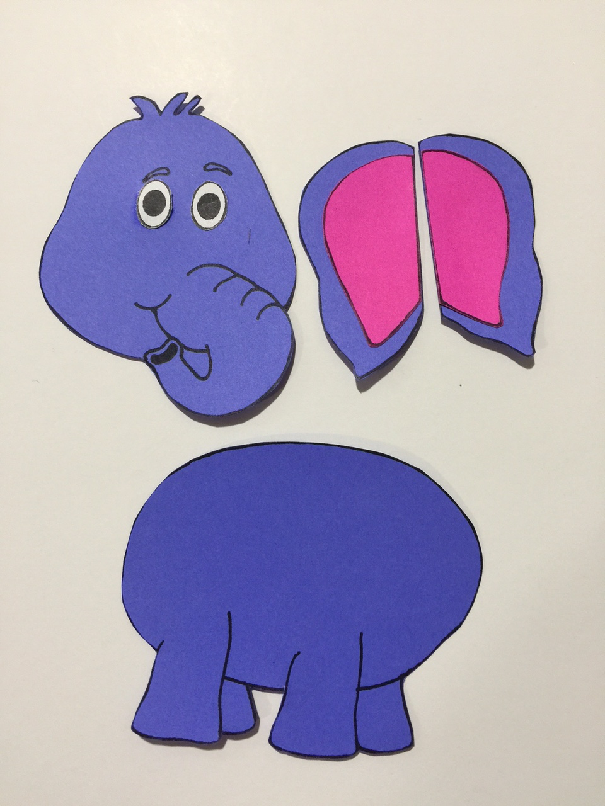

1. Glue the eyes onto the head.
2. Glue the inner pink ears onto the outer purple ears.

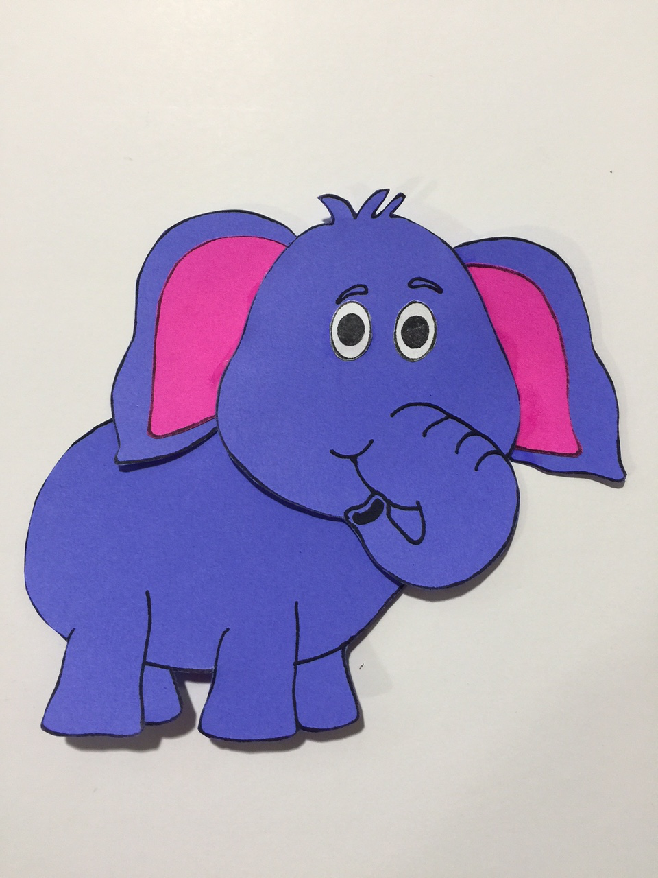

1. Glue the ears onto the back of the head.
2. Glue the head onto the body.

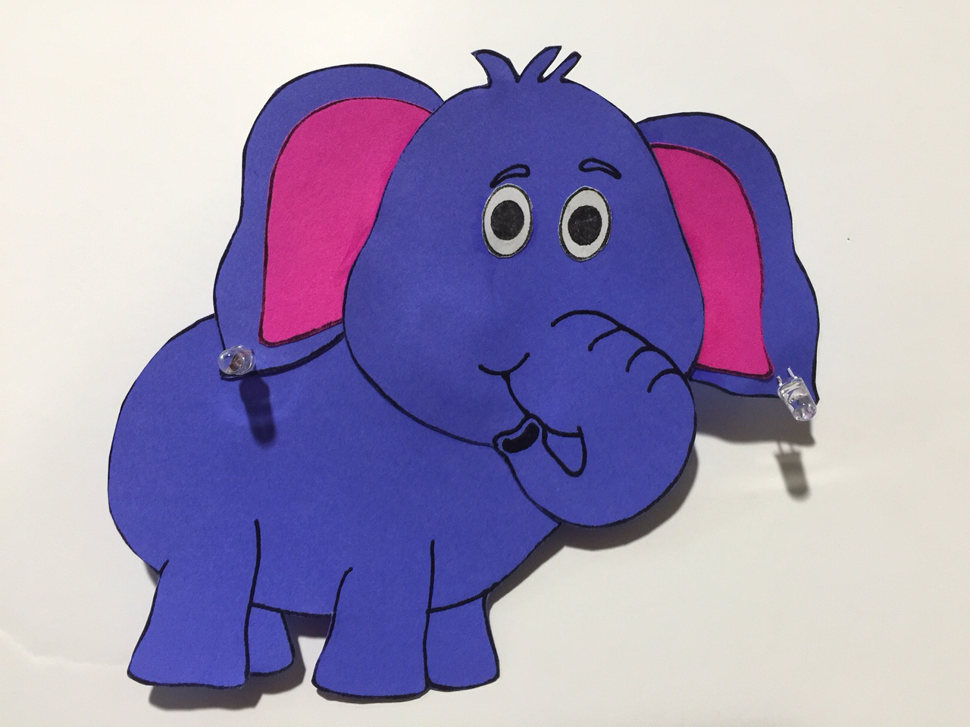

1. Using a straight pin, punch two holes for the LEDs in each of the two ears.
2. Install the LEDs through the holes. Place a small dab of glue under each LED.

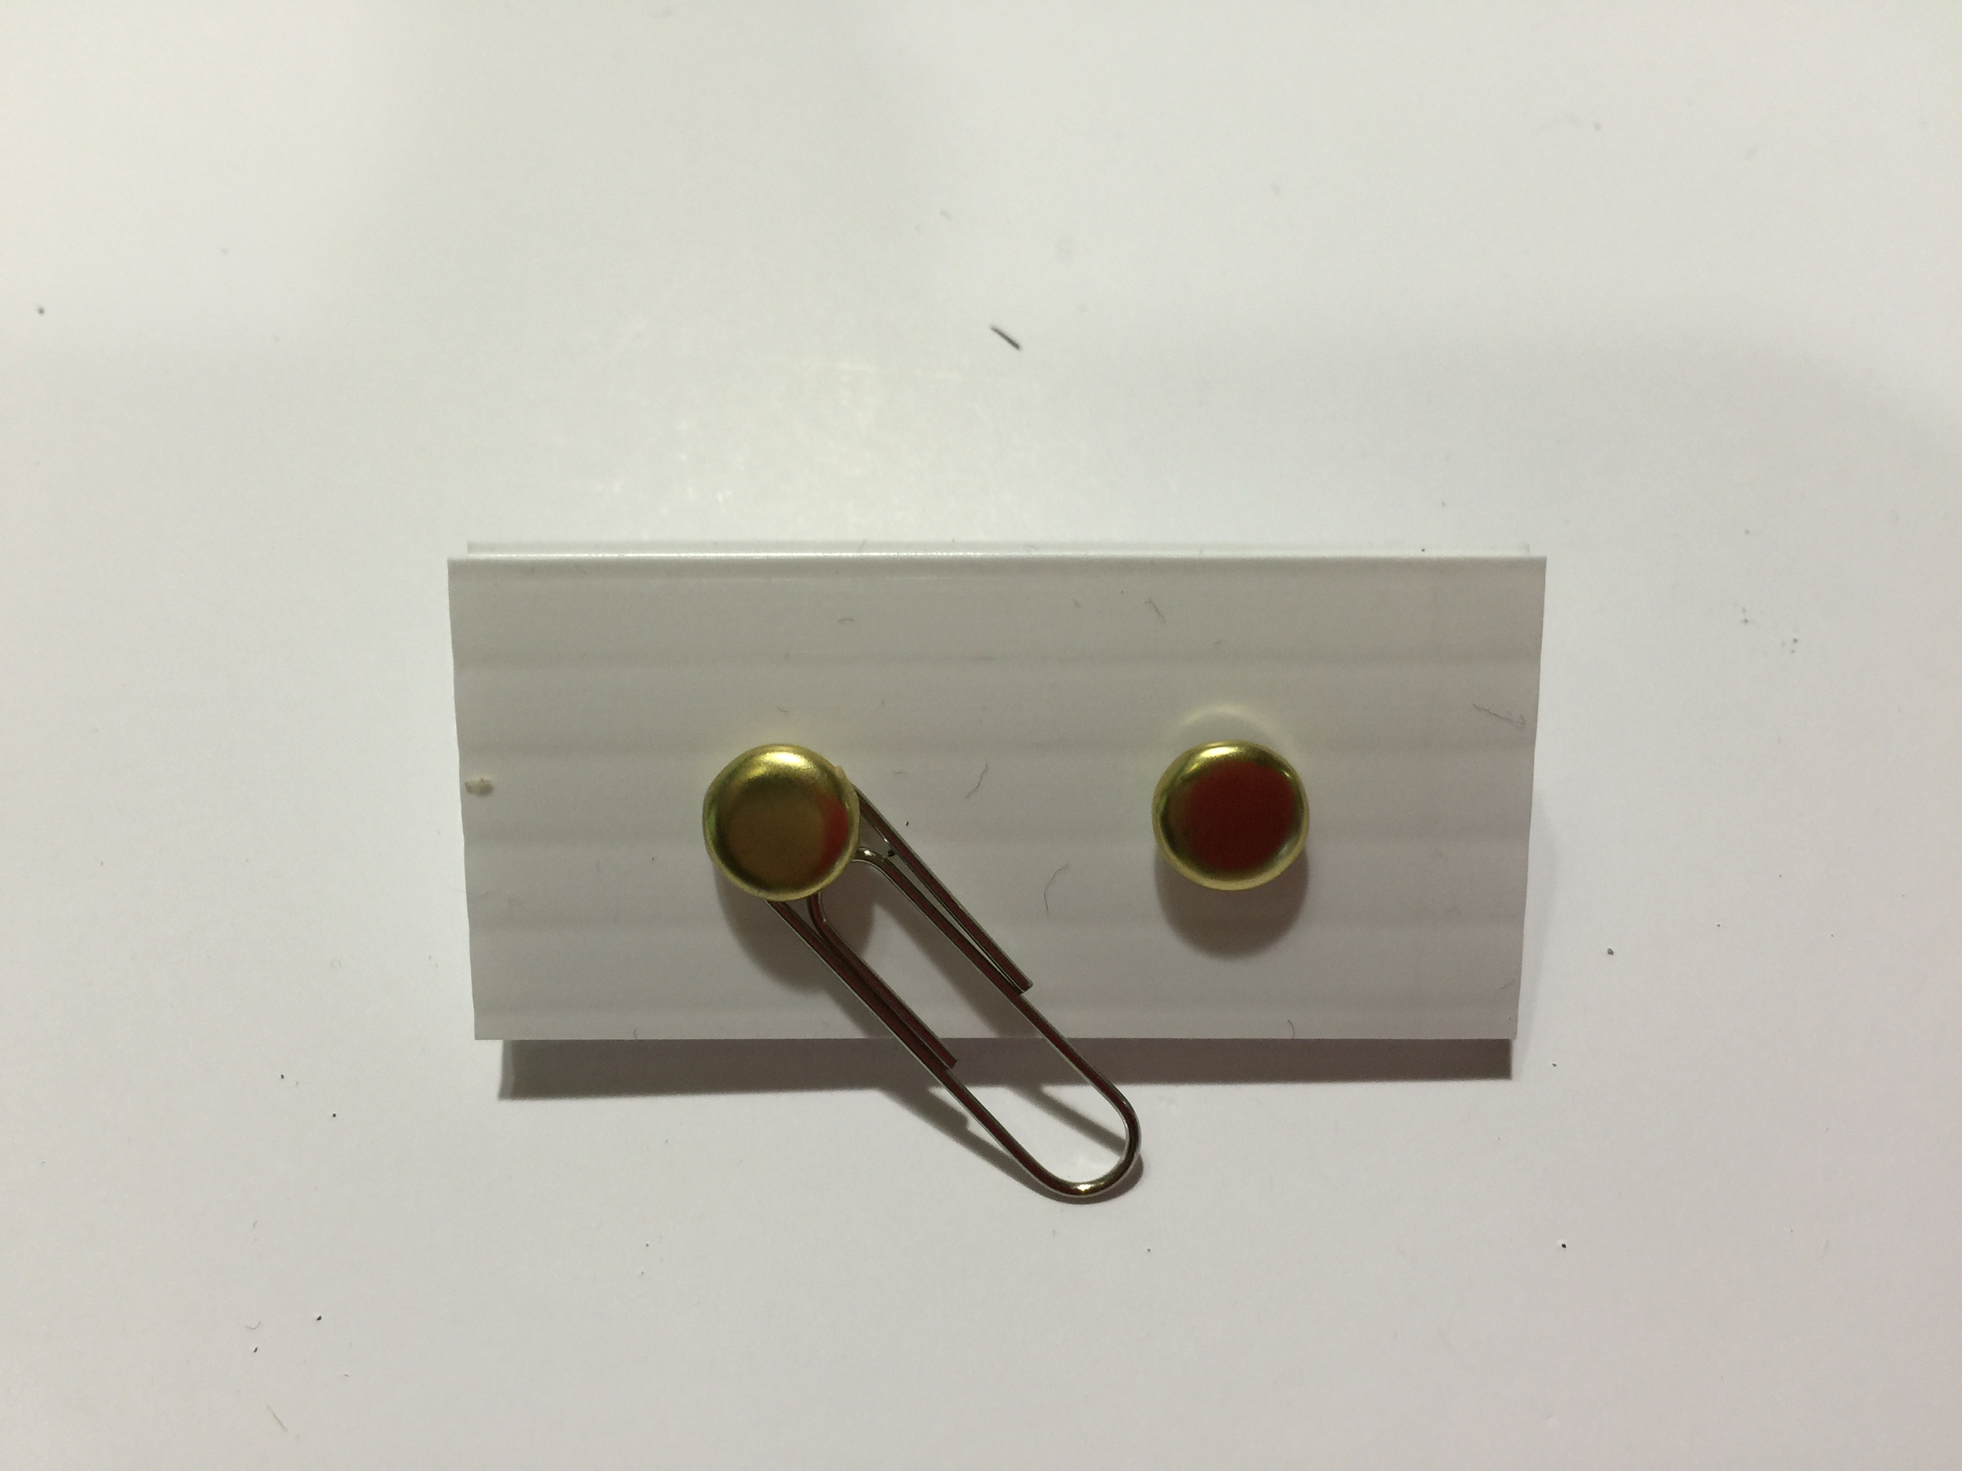

1. Assemble the switch from the corrugated rectangle, the two brads, and the paperclip according to the above picture.

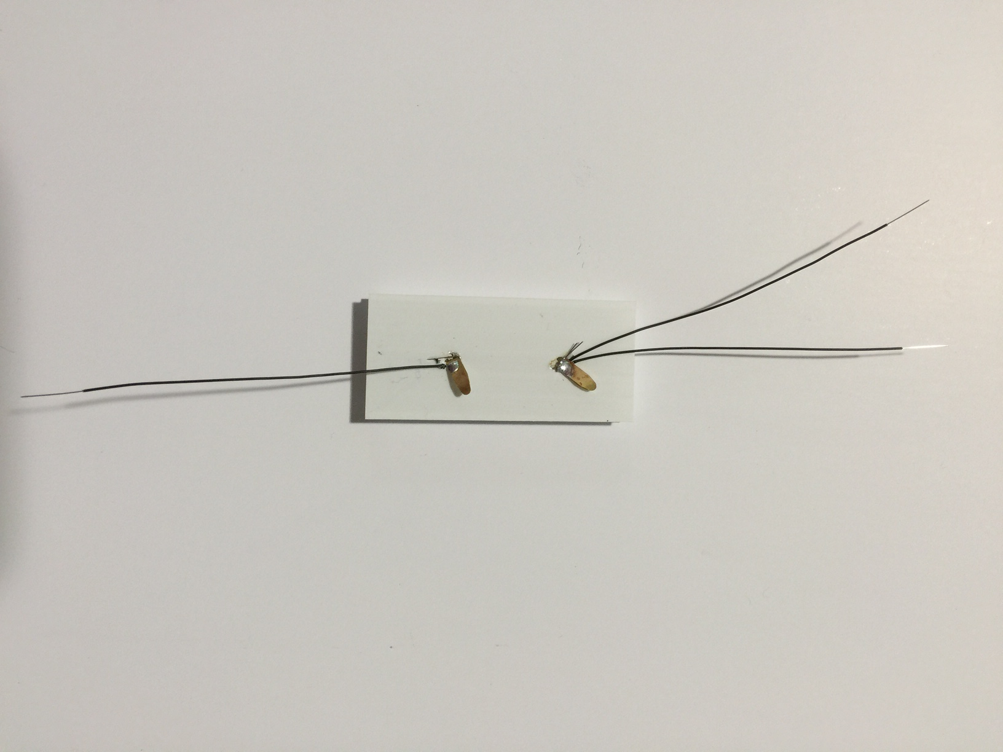

1. On the bottom of the switch, attach two black wires to one brad and one black wire to other brad. Solder in place.

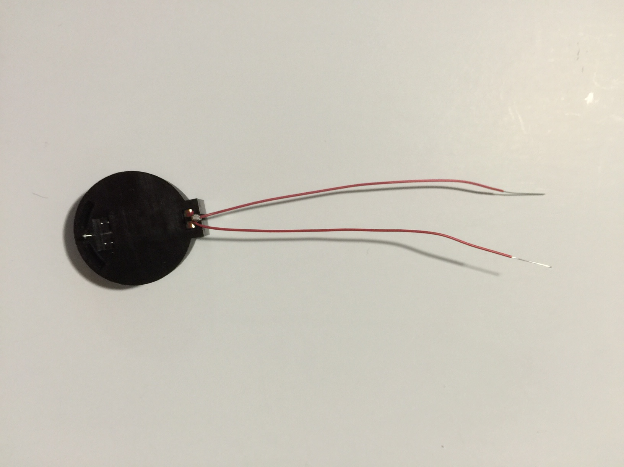

1. Using the wire wrap tool, attach two red wires to positive (larger) end of battery holder. Solder in place.

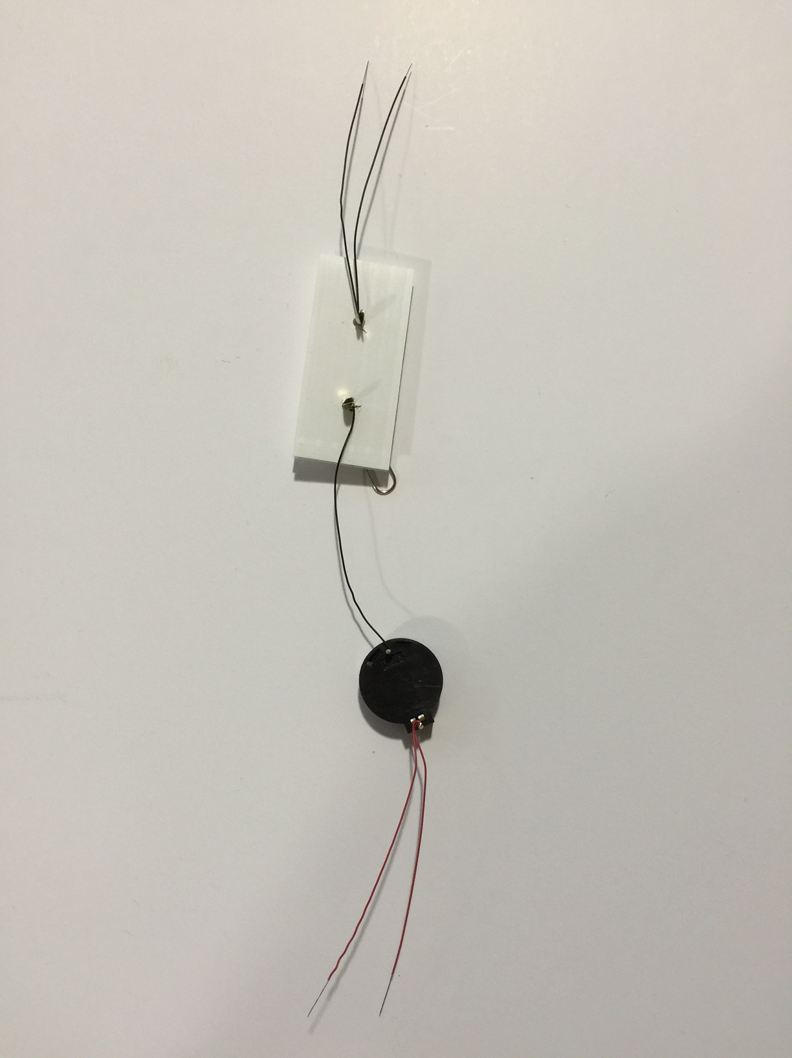

1. Using the wire wrap tool, attach the single black wire from the switch to the negative (smaller) end of the battery holder. Solder in place.

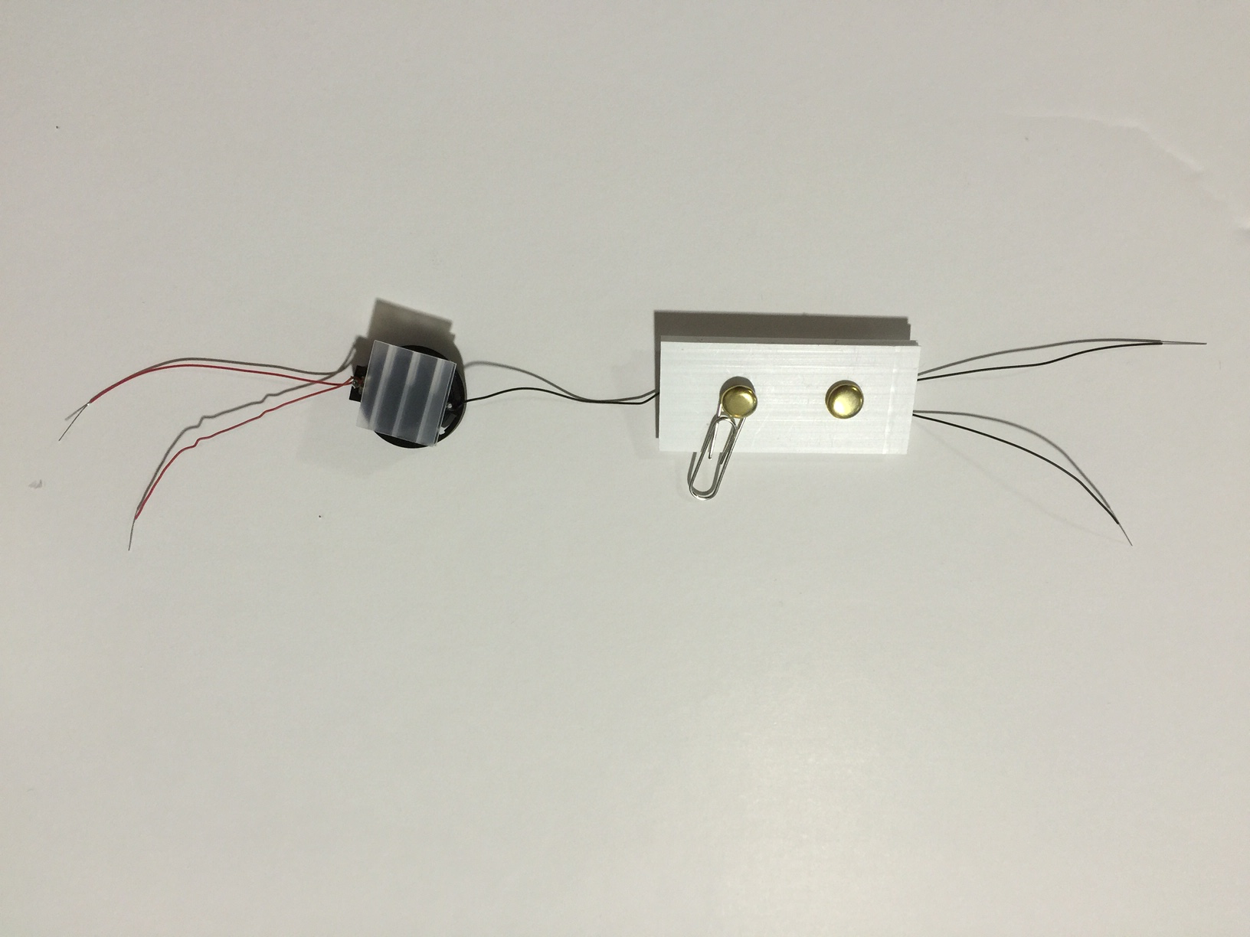

1. Hot glue the small corrugated square to the back of the battery holder.

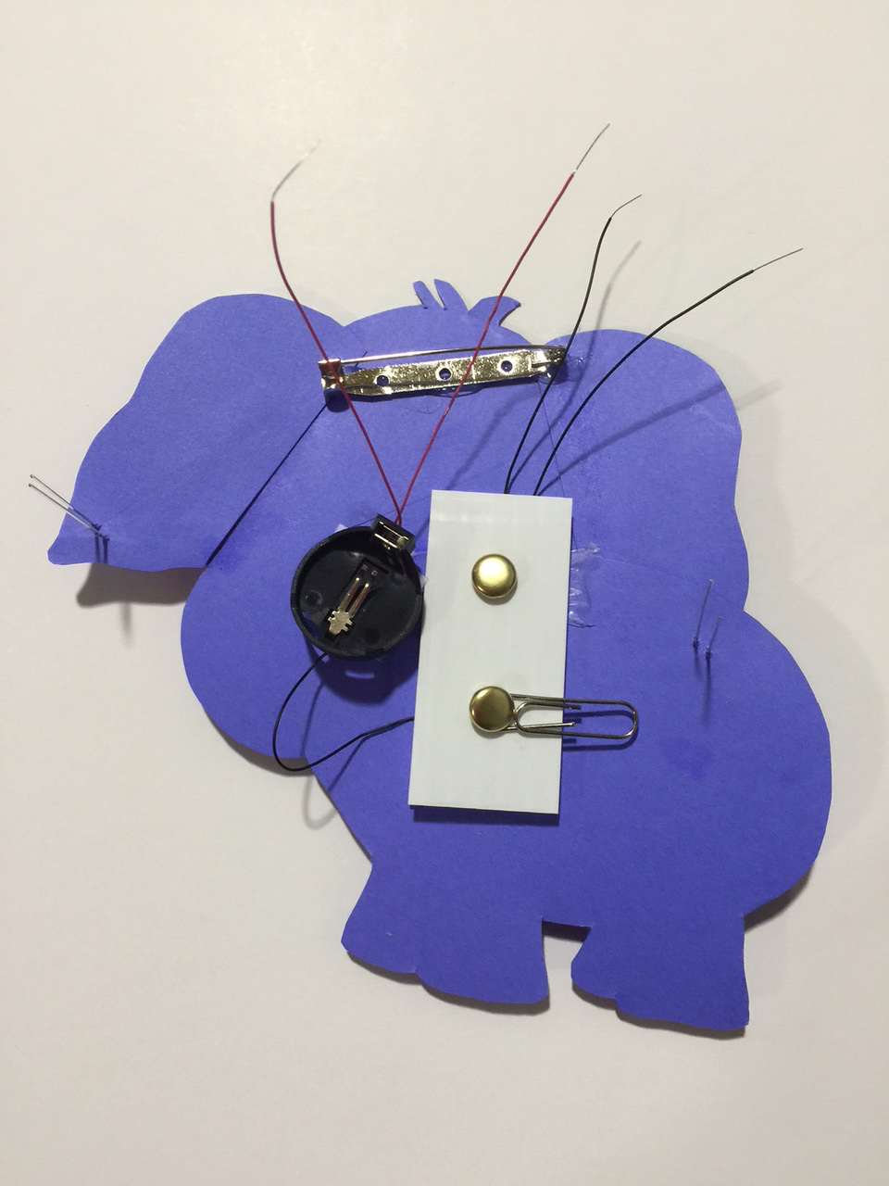

1. Working on the backside, hot glue the bar pin across the top of the head.
2. Hot glue the switch in the center of the body, making sure that the black wires will reach the LEDs.
3. Hot glue the battery holder in the center of the body, making sure that the red wires will reach the LEDs.

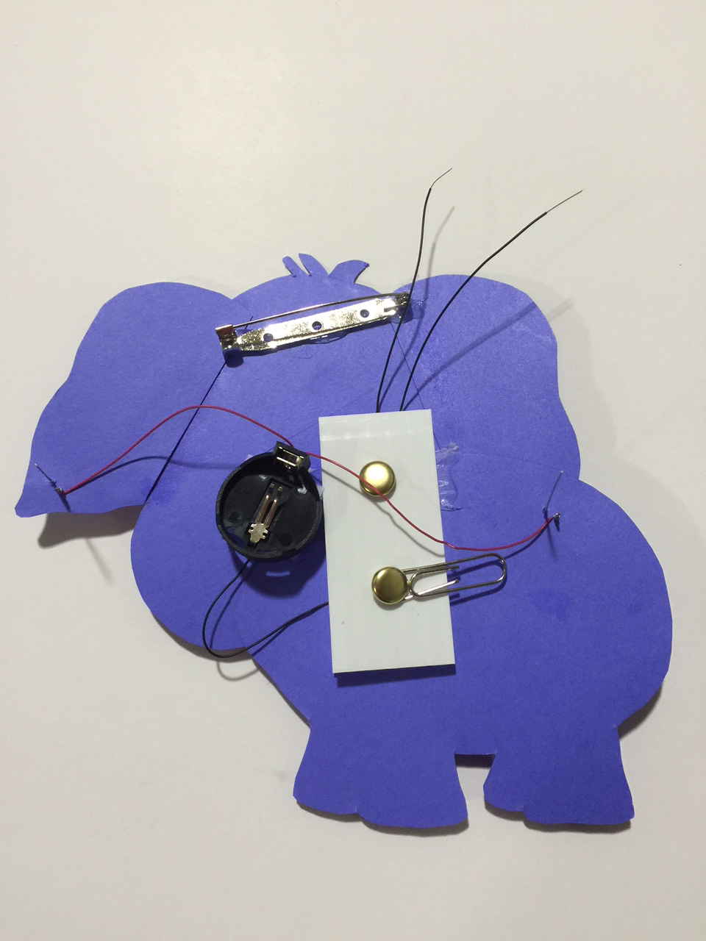

1. After putting on safety glasses, trim the two longer leads of the LEDs to ~1/4 inch.
2. Using the wire wrap tool, attach the two red wires to each of the cut LED leads. Solder in place.

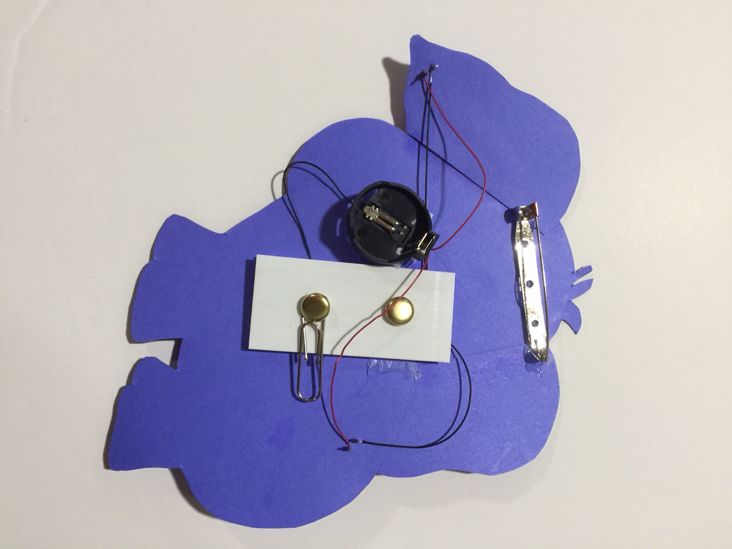

1. After putting on safety glasses, trim the two remaining LED leads to ~1/4 inch.
2. Using the wire wrap tool, attach the two black wires to each of the remaining leads. Solder in place.
3. If needed, put on safety glasses and trim the LED leads again.

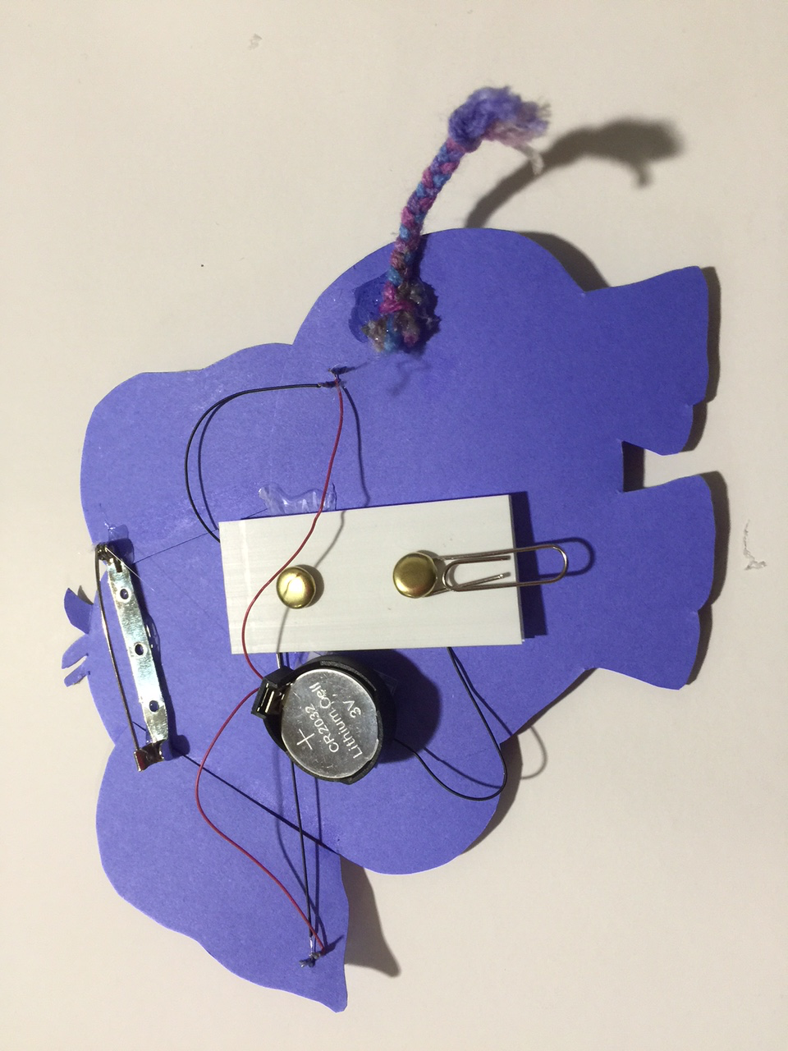

1. Tie the three pieces of yarn together at one end. Braid the yarn. Glue the tail into place on the backside of the body.
2. Install the battery so that the + side is facing up.



1. Glue the toenails on.
2. Close the paperclip switch and VOILA!

